APPENDIX L

Team Logo.

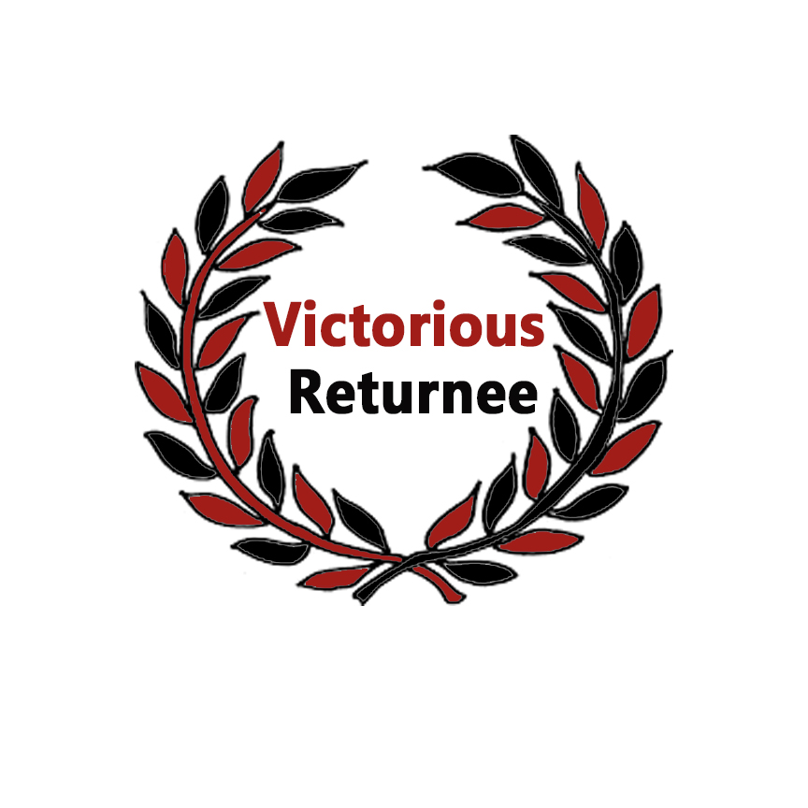

The laurel is a symbol of victory that lives on in the phrase “Resting one’s Laurel." And the returnees represents the three members of the group. The black color represents strength, seriousness, power, and authority and the red color symbolizes action, confidence, and courage.

The team logo briefly describes the returnees who has a strength and courage to finish what they have started and aims for the victory. And that is to finish their course and to be a successful person someday.

APPENDIX M

System Logo.



The system logo represents the special features of the system which are designed as education, travel and communicate icons. At the center is the name of the system itself. The font color for the text is based on the color of the company logo. Lastly, the blue color is added for the designs because the system itself uses the same color on their interfaces.

APPENDIX N

Product Packaging.

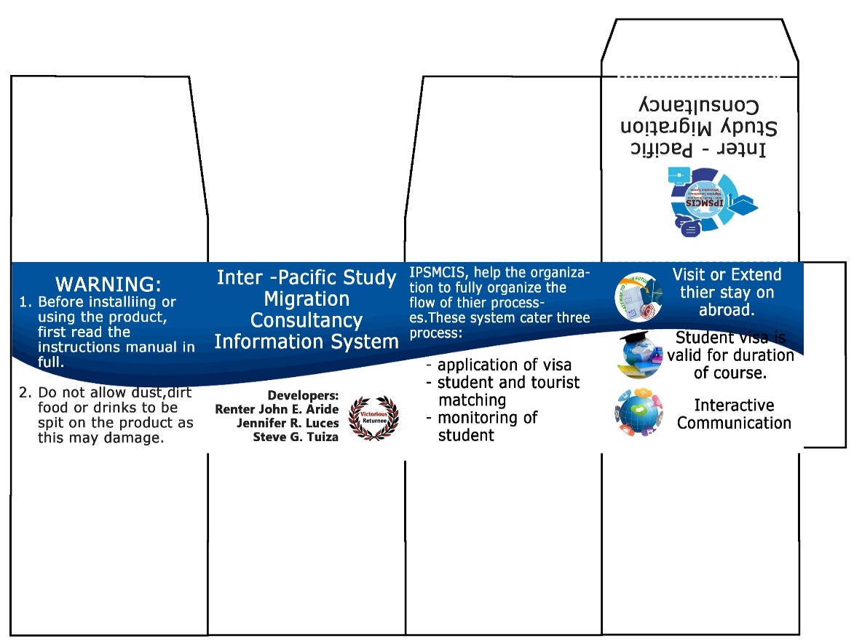

The informative design in product packaging can help a lot to sell the product because it allows potential customers to obtain the information they need to make a purchase decision. The design of the product packaging is simple, but it is more on informative type because it labels the most important features of the product which are delivered through travel, education and communication icons.

APPENDX O

Product Poster.

